Holiday Treats

The New York Times “Well Section” offers an enticing selection of recipes for vegetarian and vegan Holiday dishes from a variety of sources, “Taking the meaty bird off the table to make room for a spectacular array of vegetarian soups, sides, main courses, salads and desserts.”
Go to:
http://www.nytimes.com/projects/well/vegetarian-recipes/?nl=todaysheadlines&emc=edit_th_20131124#home
Some very enticing Vegan Main Dishes include:
- Harvest-Stuffed Portobello Mushrooms

Baked and Loaded Acorn Squash

Country ‘Meatloaf’ With Golden Gravy (Tempeh)

Country ‘Meatloaf’ With Golden Gravy

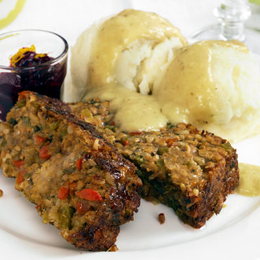

And some equally tempting Vegan Deserts: (While not as high in sugar as traditional deserts many of these are relatively high glycemic and should be modified or avoided by people requiring a low glycemic diet.)

Pumpkin Tiramisu

Chocolate-Pumpkin Bread Pudding

Pumpkin Tiramisu

Some mouth-watering Gluten Free Recipes include:

Quinoa and Cauliflower Kugel with Cumin

Vegetable Frittata with Quinoa

Gluten-Free Pumpkin Dumplings with Radicchio

